**Real-Time Process Monitoring Dashboard**

**A PROJECT REPORT**

**Submitted by:**  
MOHIT RAJ DEO (12323329) (67)  
ANURAG SHUKLA (12304680) (26)  
ARINDAM HORE (12323827) (33)  
KE016

In partial fulfillment for the award of the degree of **Bachelor of Technology in Computer Science and Engineering**  
Lovely Professional University, Punjab

**Date:** 20 March 2025



**Lovely Professional University, Punjab**

**BONAFIDE CERTIFICATE**

Certified that this project report titled **"Real-Time Process Monitoring Dashboard"** is the bonafide work of **MOHIT RAJ DEO (12323329), ARINDAM HORE (12323827), and ANURAG SHUKLA (12304680)** who carried out the project work under the supervision of **HARDEEP KAUR**, Operating System Faculty (KE016).

**Signatures:**  
MOHIT RAJ DEO  
ARINDAM HORE  
ANURAG SHUKLA

**Signature:**  
HEAD OF THE DEPARTMENT  
Department of Operating System, CSE, Lovely Professional University, Punjab

**Signature:**  
SUPERVISOR  
Department of Operating System, CSE, Lovely Professional University, Punjab

**Table of Contents**

1. Project Overview
2. Module-Wise Breakdown
   * 2.1 System Overview Module *(Refer to Image 1)*
   * 2.2 Process Manager Module *(Refer to Image 2)*
   * 2.3 Performance Graphs Module *(Refer to Image 3)*
   * 2.4 Battery and Power Management Module *(Refer to Image 4)*
   * 2.5 Task Planning and Collaboration Tools *(Refer to Image 5)*
3. Functionalities
4. Technology Used
5. Flow Diagram *(Space allocated for diagrams)*
6. Revision Tracking on GitHub *(Space allocated for screenshots)*
7. Conclusion and Future Scope *(Space allocated for diagrams or charts)*
8. References *(Space allocated for citations)*

**Project Overview**

This project is a **comprehensive Task Manager application** built with Streamlit that provides real-time system monitoring and management capabilities such as CPU, memory, disk, GPU usage tracking, process management, and battery monitoring. It also incorporates **task planning and collaboration tools**, making it a versatile solution for both individual users and teams.

**The Task Manager is particularly useful for:**

* System administrators monitoring server performance
* Developers optimizing resource-intensive applications
* End-users wanting to understand their system's behavior
* IT support personnel diagnosing system issues

**Key Features:**

* Real-time updates of system metrics.
* Interactive graphs for visualizing performance trends.
* Detailed process information and management capabilities.
* Power usage estimation and battery life prediction.
* Task planning with priority-based assignments and collaboration tools for team communication.

**Module-Wise Breakdown**

**2.1 System Overview Module *(Refer to Image 1)***

Provides a snapshot of the system's hardware and software configuration:

* Displays CPU, memory, and disk usage in real-time using intuitive gauges.
* Detailed system information such as OS version, architecture, processor details, etc.

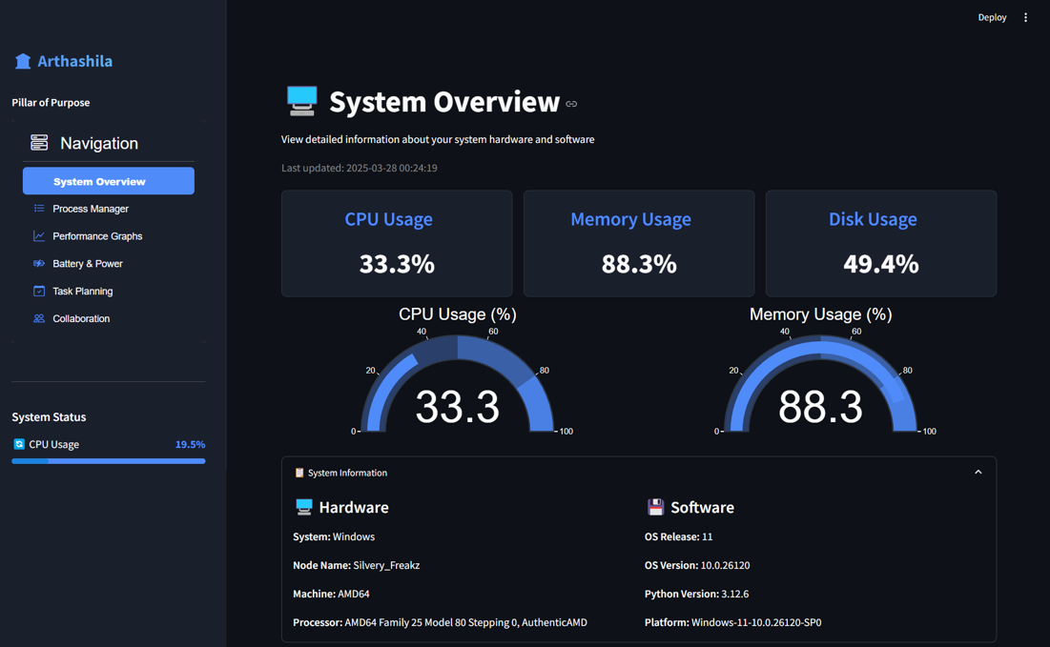

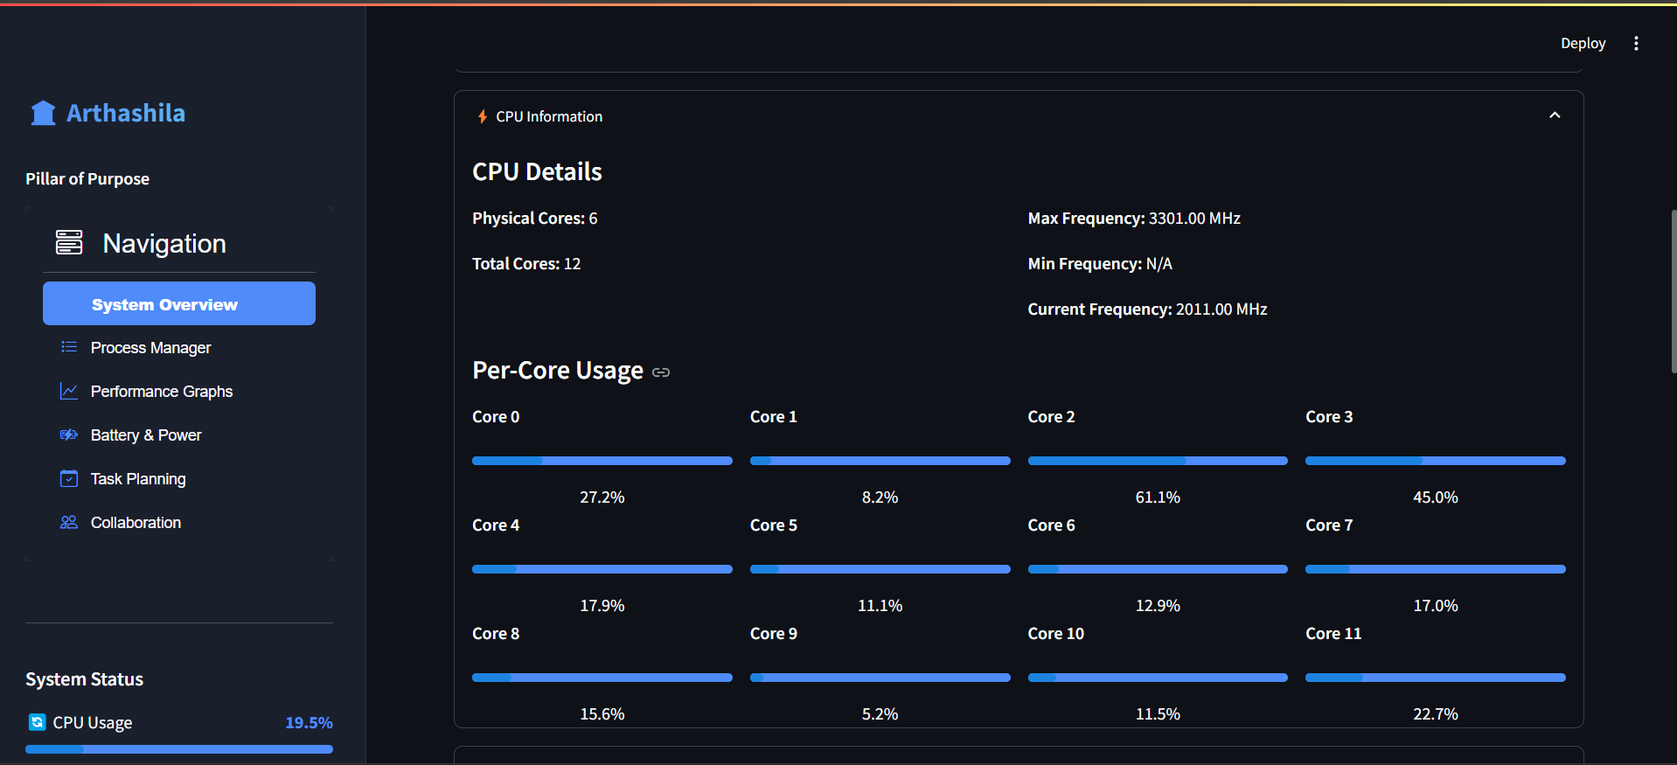

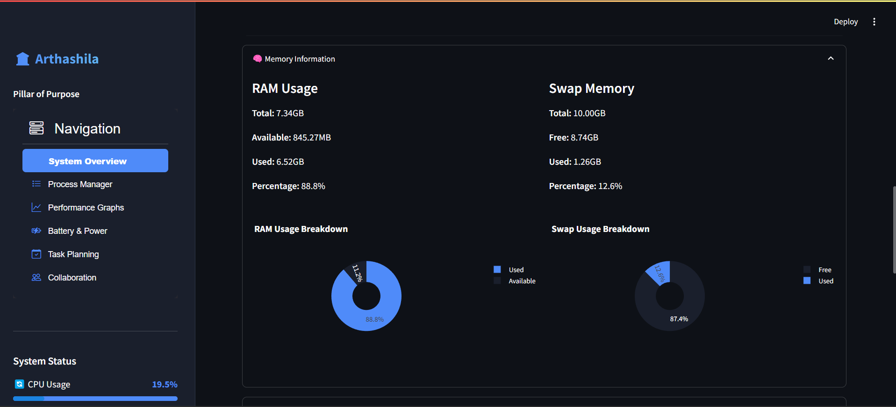

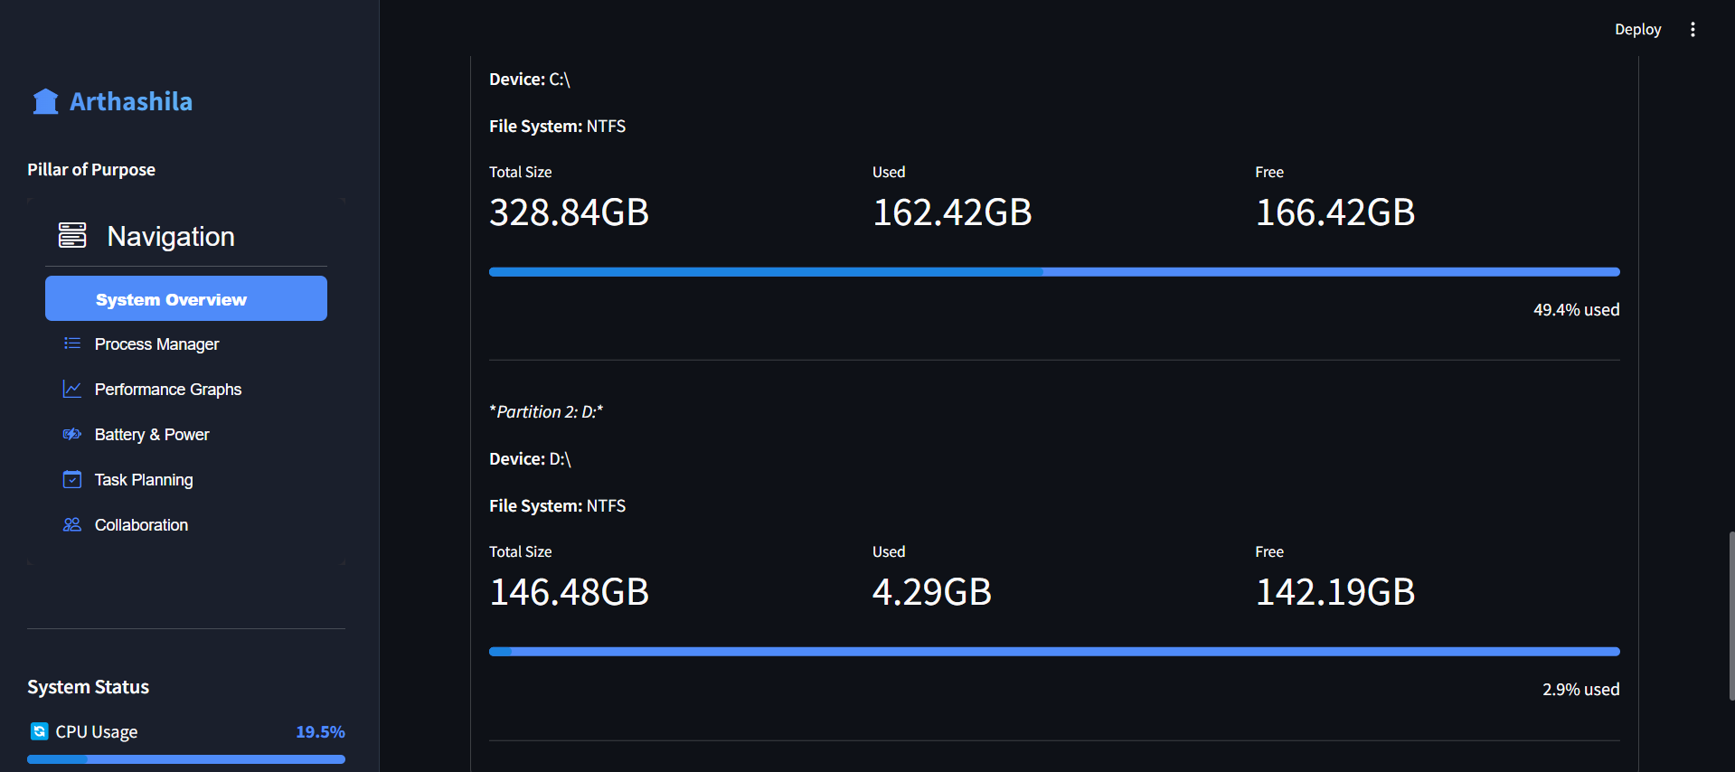

**2.2 Process Manager Module *(Refer to Image 2)***

Allows real-time monitoring and control of running processes:

* Lists active processes with CPU/memory usage metrics.
* Sorting options based on resource consumption.
* Termination of processes directly from the interface.

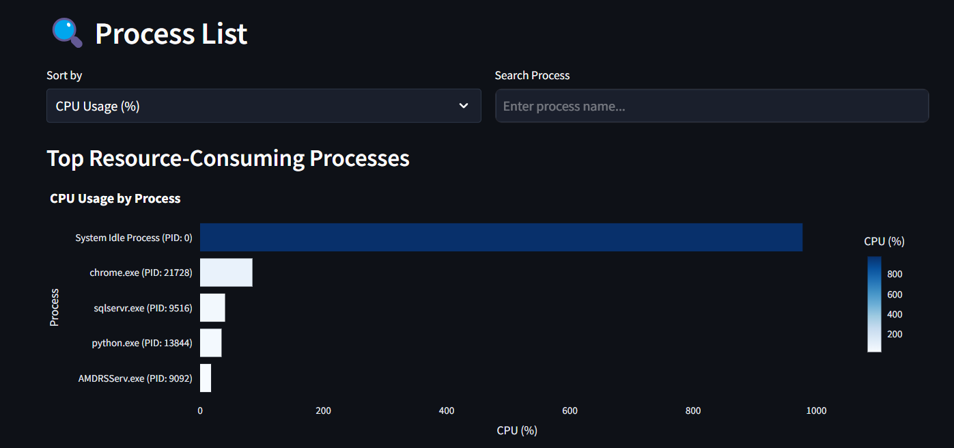

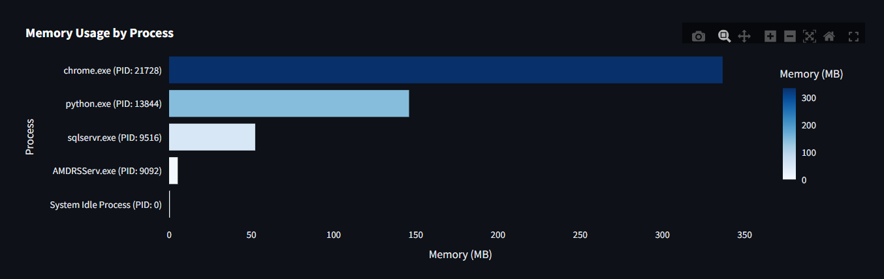

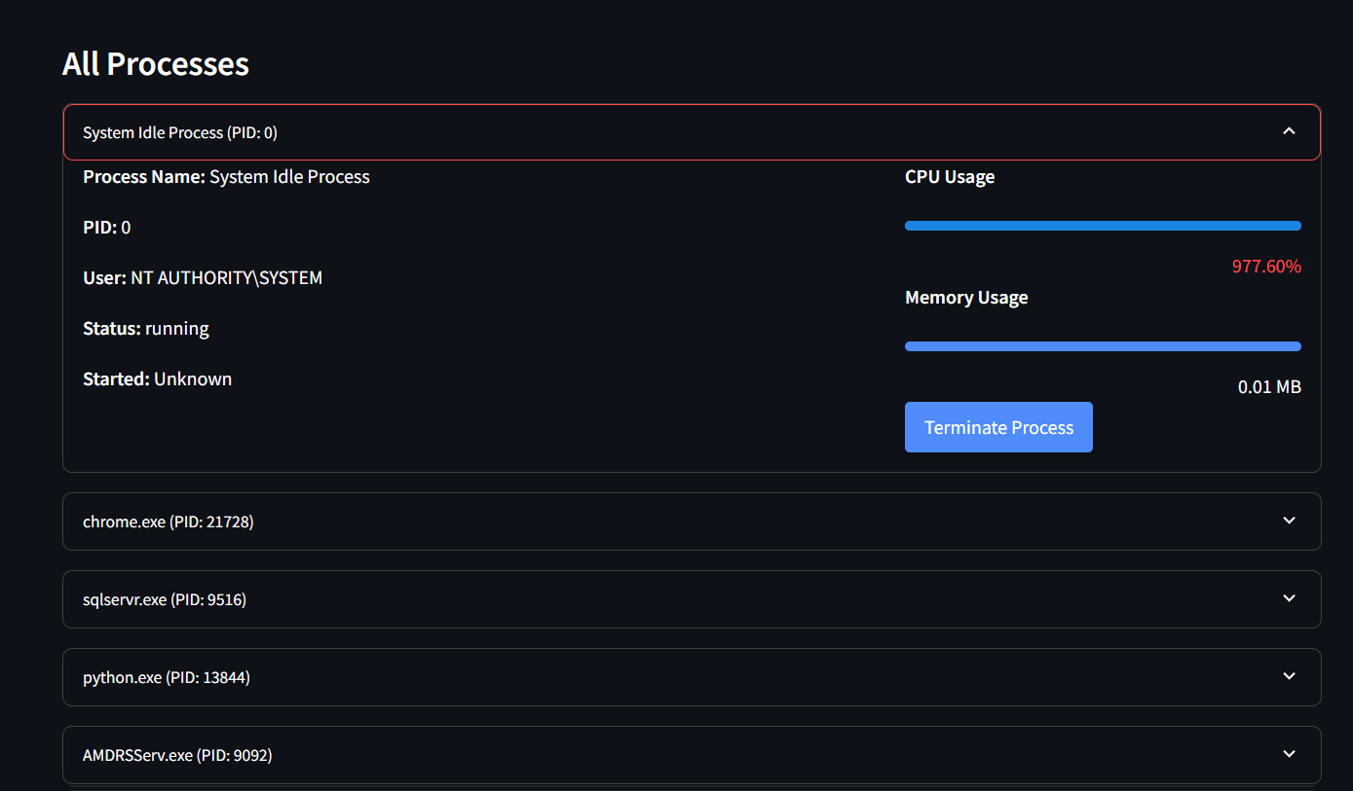

**2.3 Performance Graphs Module *(Refer to Image 3)***

Visualizes system performance metrics over time:

* Interactive graphs for CPU/memory/disk usage trends.
* Per-core CPU performance visualization.
* Network traffic monitoring.

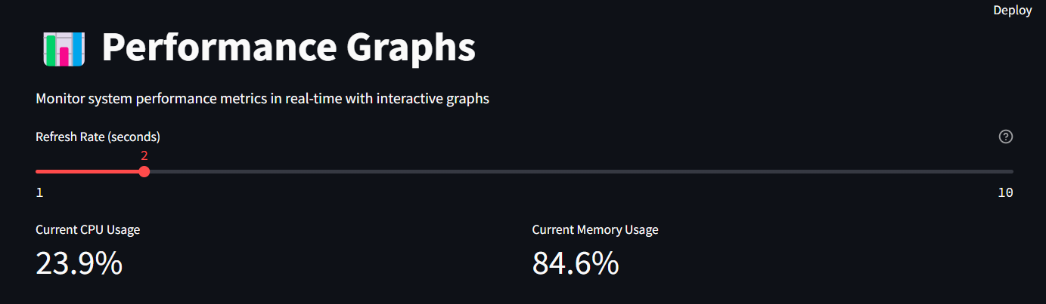

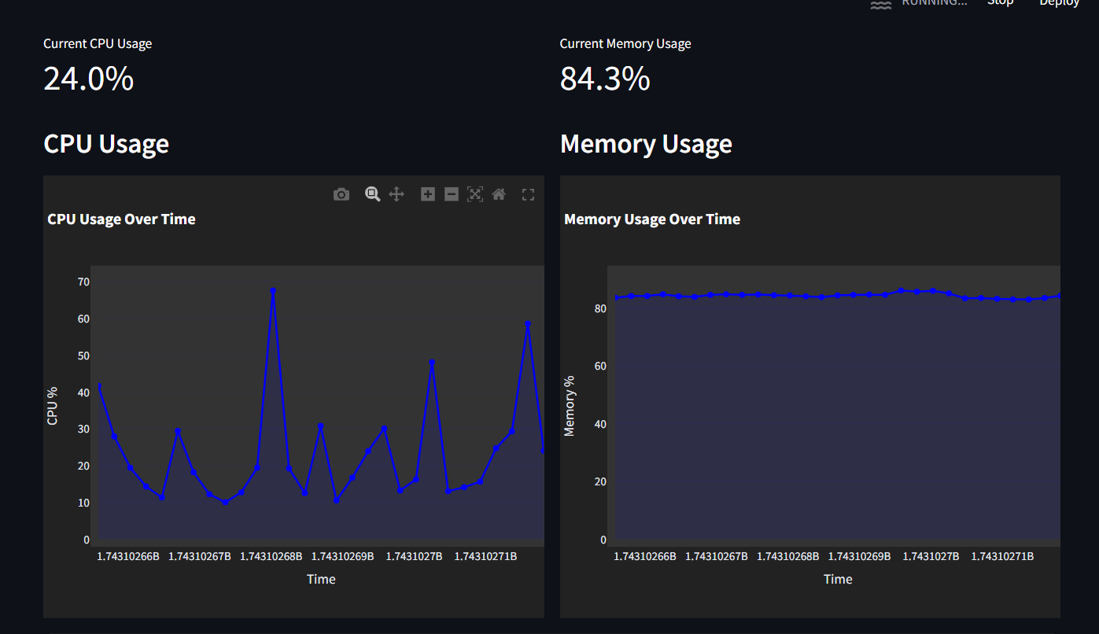

**2.4 Battery and Power Management Module *(Refer to Image 4)***

Monitors power-related metrics:

* Displays battery charge level, power consumption estimates, and remaining battery life.
* Provides power-saving tips for optimizing battery usage.

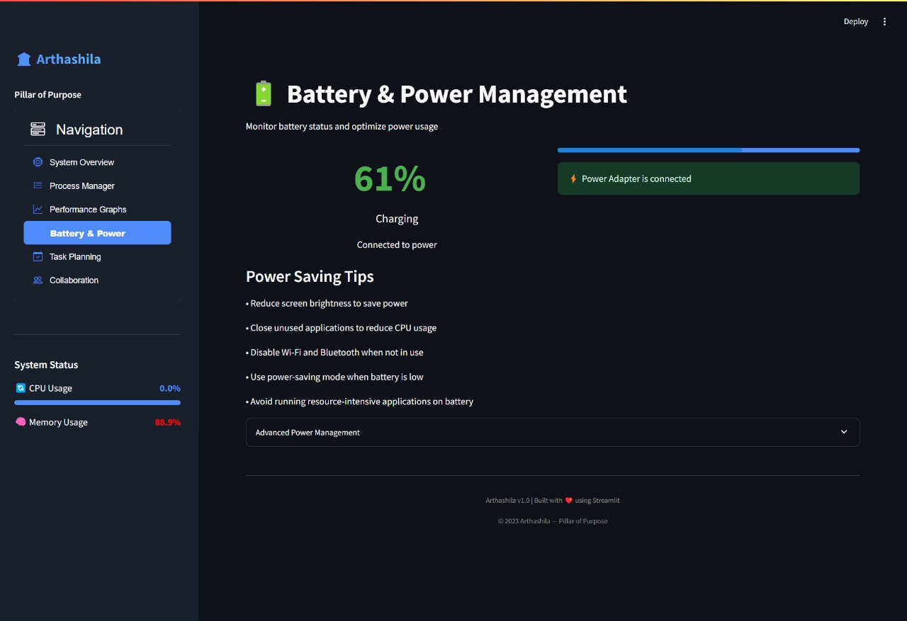

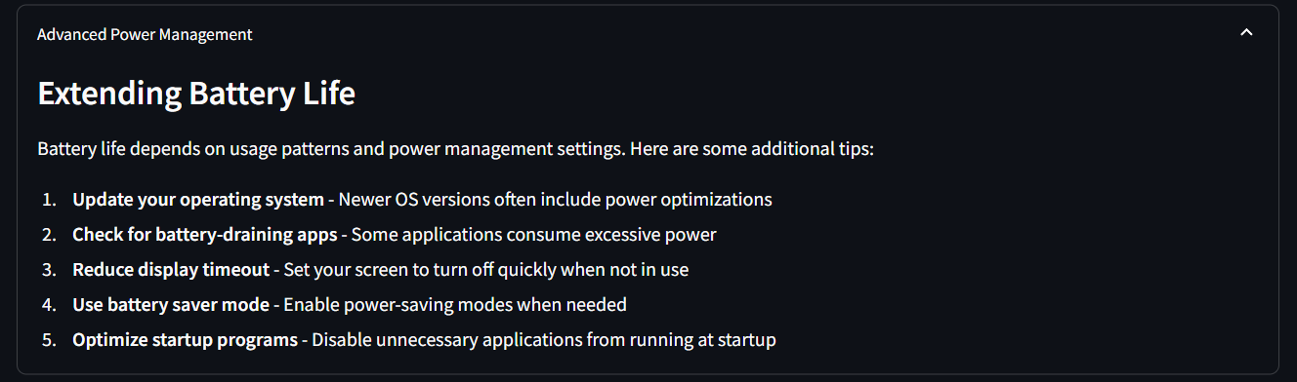

**2.5 Task Planning & Collaboration Tools *(Refer to Image 5)***

Introduces task planning and team collaboration functionalities:

* Task creation with priority levels (Low/Medium/High) and deadlines.
* Shared task lists with status tracking (Not Started/In Progress/Completed).
* Team chat module for seamless communication among members.

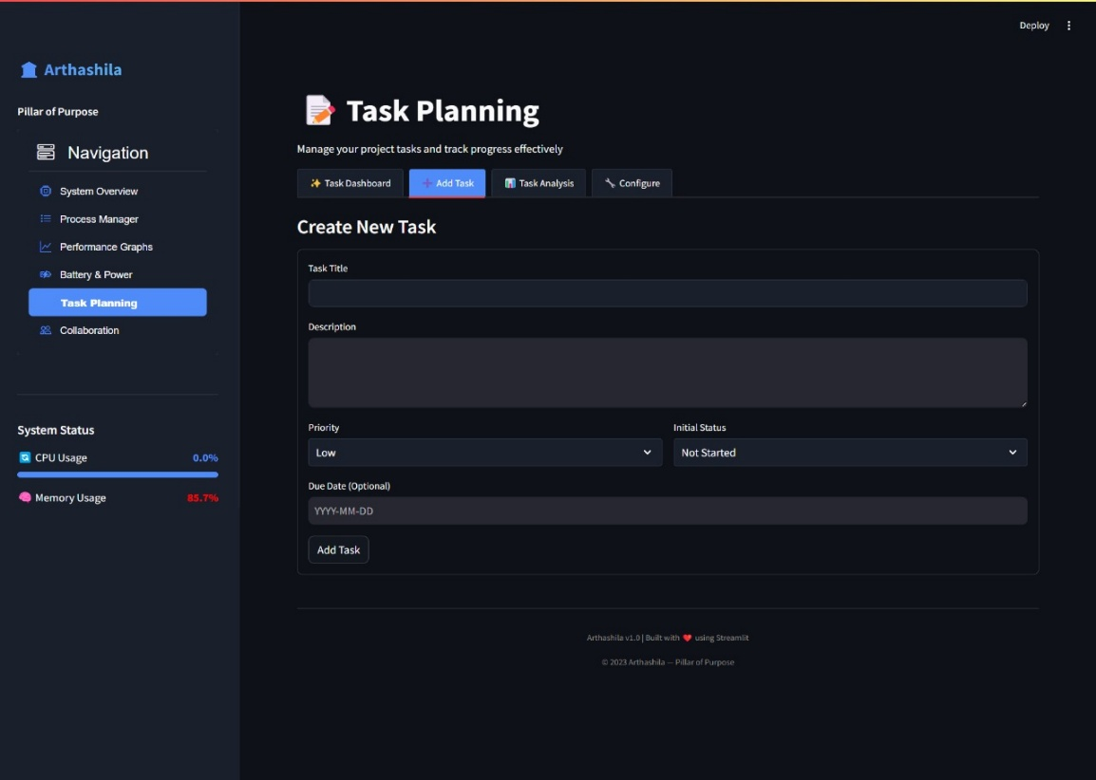

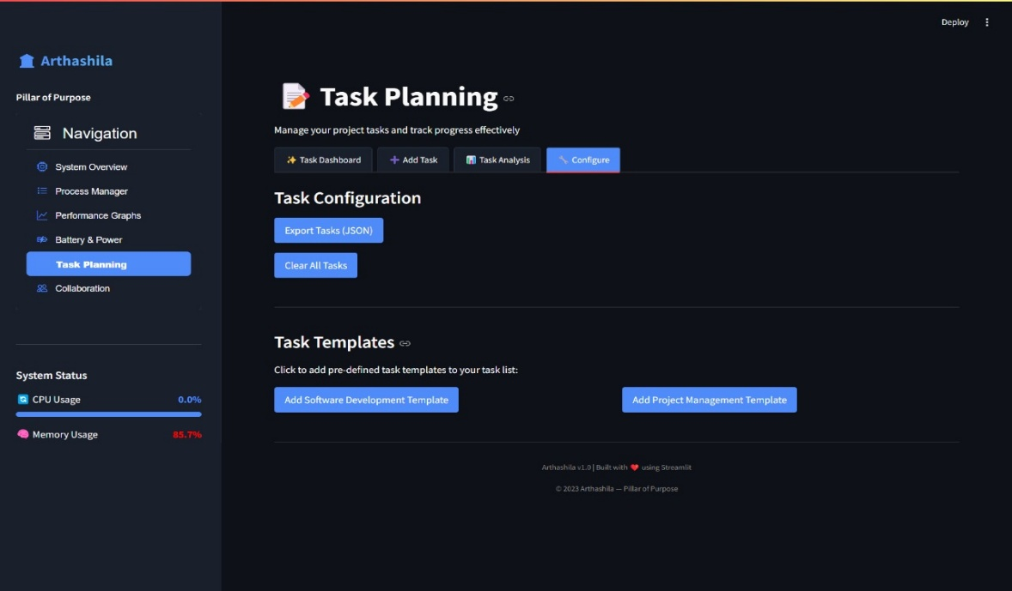

**Functionalities**

**3.1 System Information Display**

Displays detailed system information such as OS details, CPU specifications, hardware information, memory/storage capacity, etc.

**3.2 Real-Time Process Monitoring**

Lists all running processes with resource consumption details such as memory/CPU usage percentages.

**3.3 Performance Visualization**

Creates interactive graphs for various system metrics like CPU/memory/disk/GPU usage over time.

**3.4 Battery Status & Power Usage Estimation**

Monitors battery charge levels while estimating power consumption across components like CPU/RAM/GPU.

**3.5 Task Planning & Collaboration**

Enables task management with priority settings and deadlines while fostering collaboration through team chat features.

**Novelty of the Project**

The integration of a **task planning module with collaboration tools** into a real-time system monitoring dashboard is a unique aspect of this project:

1. **Task Planning Integration:** Users can create tasks with specific priorities and track their progress alongside system performance metrics.
2. **Collaboration Features:** A built-in chat module allows team members to communicate directly within the dashboard while managing shared tasks effectively.
3. **Comprehensive Utility:** Combines individual productivity tools with team management capabilities in one cohesive platform.

These features make the dashboard suitable not only for personal use but also for professional environments where teamwork is essential.

**Technologies Utilized:**

**Programming Languages:** Python

**Libraries and Tools:**

* Streamlit: For creating the web application interface.
* Psutil: For retrieving system utilization/resource metrics.
* Pynvml: For NVIDIA GPU monitoring.
* Plotly: For interactive graph creation.
* Tabulate: For tabular data formatting.

**Flow Diagram**

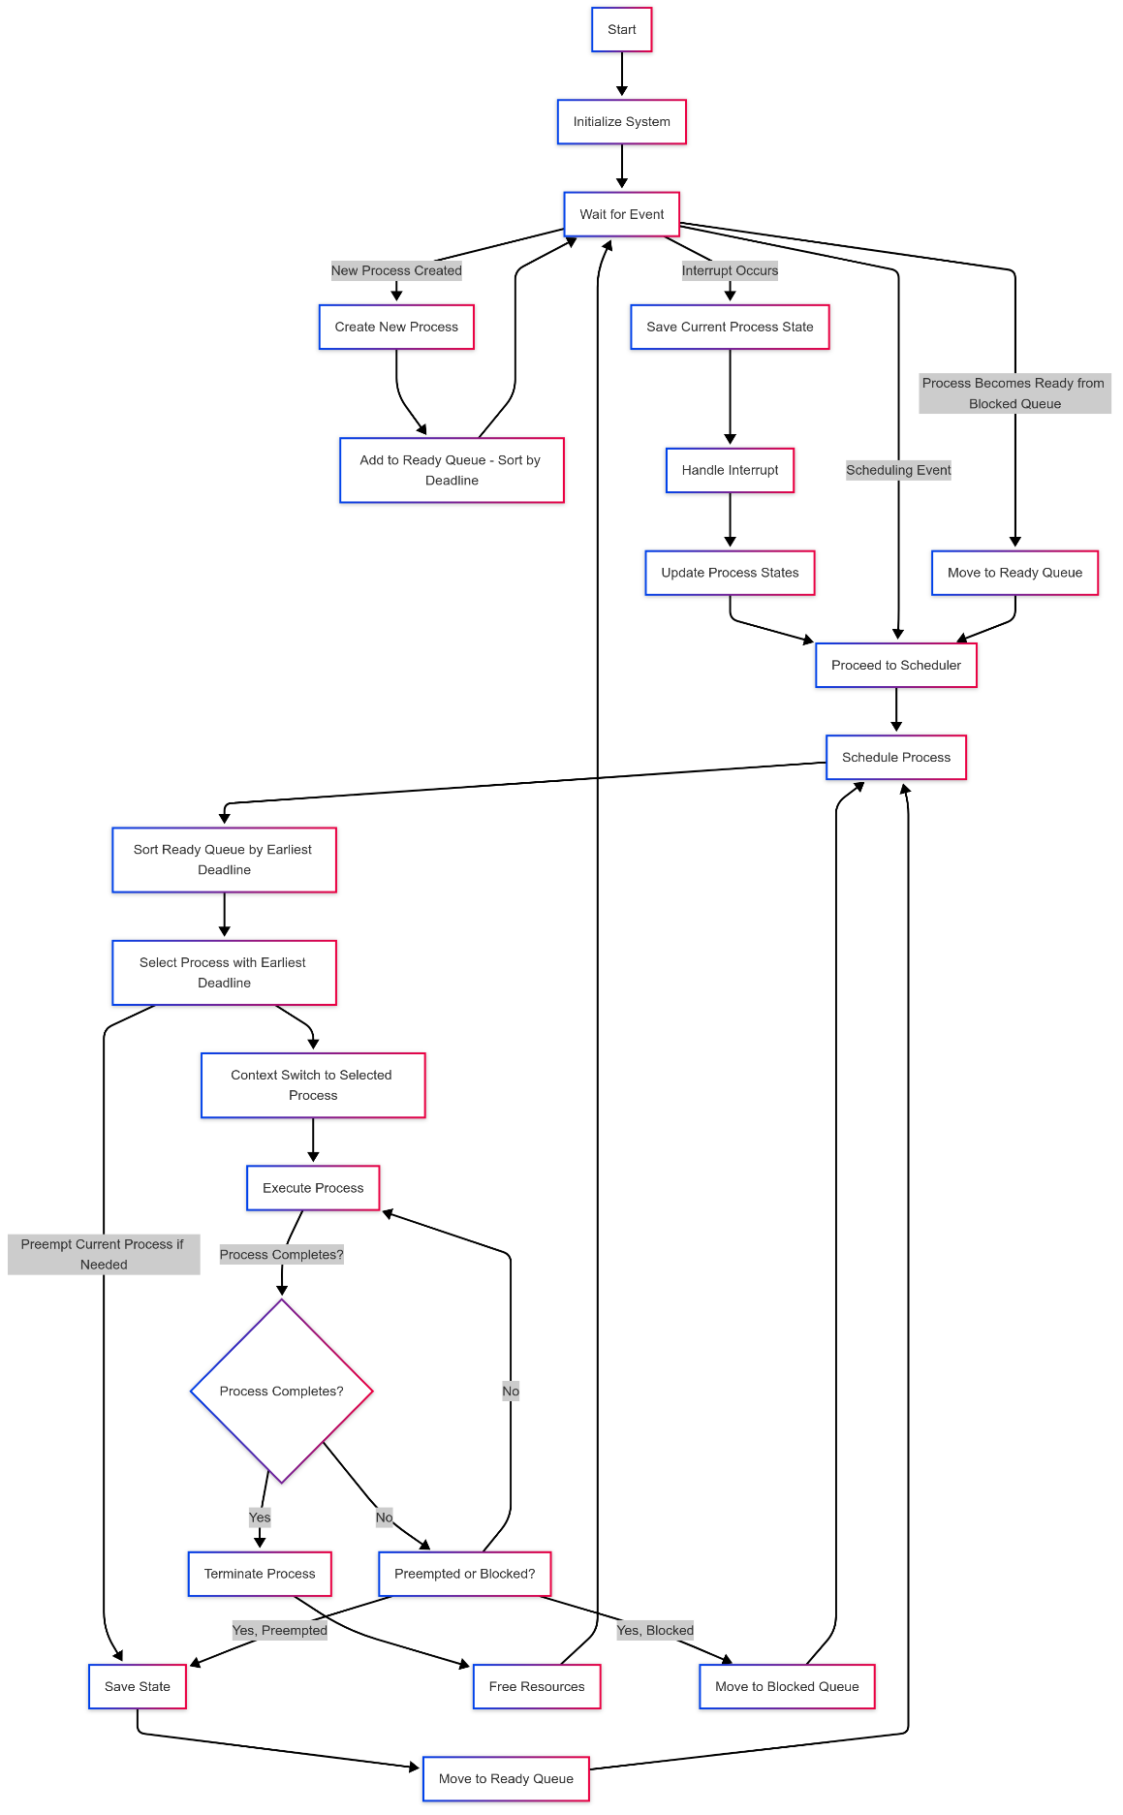

**Revision Tracking on GitHub:**

* Repository Name: Arthashila
* GitHub Link: [Arthashila](https://github.com/ArindamHore-Student/Arthashila)

Proper use of GitHub includes regular commits with descriptive messages to track progress efficiently.

**Conclusion & Future Scope**

The Task Manager dashboard effectively integrates multiple system monitoring aspects into a cohesive interface, offering real-time updates to users. It leverages machine learning capabilities to automate task management, detect anomalies, and optimize resource utilization. This combination ensures proactive system maintenance and improves overall efficiency.

**Future Enhancements:**

1. **Network Traffic Analysis:**
   * Implementation of detailed network traffic breakdowns by application, providing insights into bandwidth usage and potential bottlenecks.
2. **Customizable Alerts:**
   * Development of personalized alert systems for resource usage thresholds, allowing users to set specific parameters for CPU, memory, and disk usage.
3. **Historical Data Logging:**
   * Integration of historical data logging with trend analysis to identify long-term performance patterns and predict future resource needs.
4. **Enhanced GPU Monitoring:**
   * Advanced GPU monitoring with support for multi-GPU environments, facilitating high-performance computing and machine learning workloads.
5. **Advanced Collaboration Tools:**
   * Introduction of collaboration tools, such as file sharing and video conferencing integration, to enhance teamwork and communication within the platform.
6. **Artificial Intelligence (AI) Implementation:**
   * Incorporation of AI models to enhance predictive maintenance by identifying potential failures before they occur.
   * Adaptive learning algorithms to optimize resource allocation dynamically based on workload patterns.
   * Intelligent automation for routine administrative tasks, reducing manual intervention and minimizing human error.

The continuous evolution of the Task Manager dashboard with these enhancements will ensure a robust, intelligent, and user-friendly system for real-time process management and system optimization.